**16-BIT DIVISION**

**EXP NO: 8**

**AIM:** To write an assembly language program to implement 16-bit divided by 8-bit using 8085 processor.

**ALGORITHM:**

1) Read dividend (16 bit)

2) Read divisor

3) count <- 8

4) Left shift dividend

5) Subtract divisor from upper 8-bits of dividend

6) If CS = 1 go to 9

7) Restore dividend

8) Increment lower 8-bits of dividend

9) count <- count - 1

10) If count = 0 go to 5

11) Store upper 8-bit dividend as remainder and lower 8-bit as quotient

12) Stop

**PROGRAM:**

LDA 8501

MOV B,A

LDA 8500

MVI C,00

LOOP:CMP B

JC LOOP1

SUB B

INR C

JMP LOOP

STA 8503

DCR C

MOV A,C

LOOP1: STA 8502

RST 1

**INPUT&OUTPUT:**

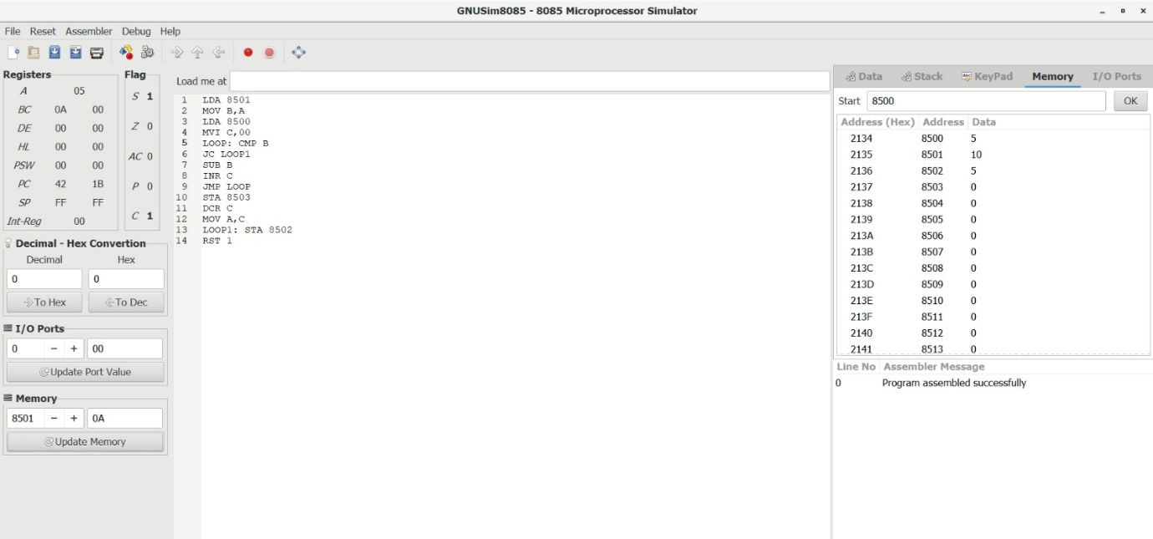

**RESULT:** Thus, the program was executed successfully using 8085 processor simulators.